|  |  |  |  |  |  |
| --- | --- | --- | --- | --- | --- |
| Area | Blade-1 and Blade-2 connectivity with the Storage got disconnected | Case No: |  | Date: | Oct 06, 2021 |
| Person: | SK Faisal | ID: | FT0148 | Mob: | 01921076556 |

**Section 1:** Description of the Incident (**Add attachment if required**)

|  |
| --- |
| **Description:**   1. Blade-1 and Blade-2: OS were running, but the connection to the Storage server went offline 2. WWN number of SAN Switch were not connecting to the provided fabric switch through LUN 3. Because of the above 2 internal connectivity, storage server could not be connected 4. Therefore, associated VM’s running on those mentioned blade servers lost connectivity and operational activity 5. All other blade servers were operational |

**Section 2:** Description of the Impact (**Add attachment if required**)

|  |
| --- |
| **Description:**  Following services users were impacted   1. USSD for all MNO 2. All other services (Bill pay, Utility etc.) using USSD |

**Section 3:** Findings of the Investigation (**Add attachment if required**)

|  |  |  |  |  |  |
| --- | --- | --- | --- | --- | --- |
| Incident | | | Resolution | | |
| Sep 09, 2021 | 9:40pm | | Sep 10, 2021 | | 11:40pm |
| **Description:**   1. Connector that were used to connect the WWN through the framework failed 2. DELL technical onboarded and replaced the failed files, installed/updated relevant firmware 3. Restarted the server, and one by one all VM’s were getting connected | | | | | |
| **Severity: High** | | | | | |
| High | | Medium | | Low | |

**Section 4:** Chronology of Events / Escalation Process / Solution (**Add attachment if required**)

|  |
| --- |
| **Chronology of Events / Escalation Process / Solution**   1. Screenshots attached below |

**Section 5:** Status of the Incident

|  |
| --- |
| Description:  After 12.30am in the morning, both blades became up and all services were operational |

**Section 6:** Knowledge Desk (**Add attachment if required**)

|  |
| --- |
| **Resolution Process:**  If the similar incident takes place, below steps will ensure quick recovery.   1. Connector that was used to connect the WWN through the framework failed 2. DELL technical onboarded and replaced the failed files, installed/updated relevant firmware 3. Restarted the server, and one by one all VM’s were getting connected |

**Section 7:** Submission Details

|  |  |
| --- | --- |
| Report Submitted By | Report Reviewed By |
| (Name & Sign :…………………..) | (Name & Sign :…………………..) |

**Evidence:**

**Section 2:** Description of the Impact (Artifact)

Following services for USSD users were unresponsive

1. USSD were inaccessible.
2. All other services (Bill pay, Utility etc.) using USSD.

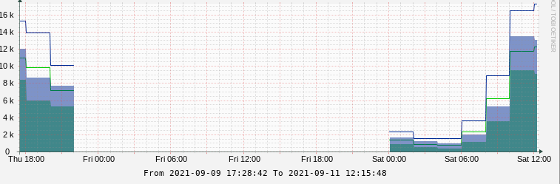

**Section 3:** Findings of the Investigation

Reference to the DELL reply of the cause: screenshot provided below of their explanation

**Section 4:** Chronology of Events / Escalation Process / Solution

1. Blade-1 and Blade-2: OS were running, but the connection to the Storage server went offline
2. WWN number of SAN Switch were not connecting to the provided fabric switch through LUN
3. Because of the above 2 internal connectivity, storage server could not be connected
4. Therefore, associated VM’s running on those mentioned blade servers lost connectivity and operational activity

Clarification of the issue from dell support:

